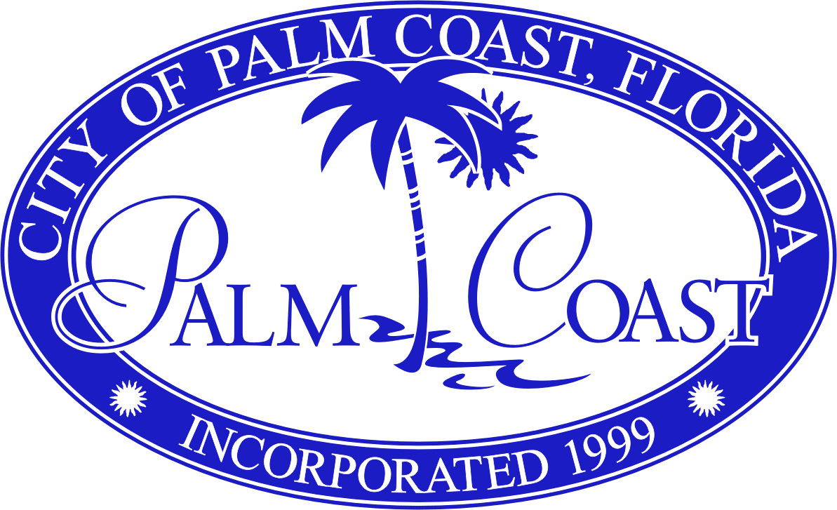

CLASSIFICATION DESCRIPTION

TITLE: BENEFITS SPECIALIST JOB CODE: 10 (Non-Exempt)

GENERAL DESCRIPTION OF DUTIES

Under general supervision, the purpose of the position is to perform complex and specialized administrative support and paraprofessional work in the field of human resources. Employees in this position function at paraprofessional level to accomplish assigned functions according to established schedules, calendars, projects, and programs of the department. Work includes, but is not necessarily limited to, core administration of the employee benefits program to include education, orientation, enrollment, changes and coordination of the annual open-enrollment period and wellness fair. Position performs both routine and non-routine administrative duties as dictated by the nature of the assigned task. Objective is to facilitate and assist in all facets of the employee benefit experience.

SPECIFIC DUTIES AND RESPONSIBILITIES

The list of essential functions, as outlined herein, is intended to be representative of the tasks performed within this classification. It is not necessarily descriptive of any one position in the class. The omission of an essential function does not preclude management from assigning duties not listed herein if such functions are a logical assignment to the position.

- Receives inquiries and requests from employees and the general public, through friendly, professional customer service skills, ascertains the needs of the customer and provides appropriate assistance and information; responds to escalated customer service issues.

- Educates, counsels, and orients all employees to the offerings of the comprehensive benefits package provided by the City of Palm Coast. Performs new hire enrollment and facilitates changes in family status.

- Processes and monitors all claims for short- and long-term disability. Assists employee in applying for benefits, communicates with the insurance company as needed and completes a variety of income verification and other reports. Ensures that employee timecards reflect periods of extended absence.

- Processes and monitors all workers’ compensation claims taking an active lead in ensuring staff attend related medical appointments, confirm restrictions, if any, to return injured worker to duty as quickly as possible. Ensures that employee timecards reflect periods of extended absence.

- Coordinates the annual open-enrollment process educating staff on plan and carrier changes, assists with the annual on-line enrollment process and oversees completion of required documents; with other staff, coordinates the verification that on-line changes are accurately imported to the payroll system and provide accurate enrollment information to plan carriers.

- Works with employees and vendor representatives, resolves claims questions and issues according to established plan documents and standards.

- Performs administrative functions relative to the enrollment in the City retirement program, monitors plan administrator website for new/expiring loans, and processes necessary forms for staff enrollment and roll-overs.

- Educates staff with anticipated medical leaves regarding their rights under the Family and Medical Leave Act; tracks leave taken with regards to Federal guidelines.

- Coordinates the annual wellness fair including the solicitation of vendor/community participants; notifies staff of fair schedule and assists in the scheduling of the annual Health Risk Assessment.

- With associated staff, reconciles bills and invoices related to the health insurance and benefits program.

- Maintains human resources information and databases; maintains a variety of human resources records and performs related posting and calculations, e.g., compensation, benefits, tax data, attendance, performance reviews, evaluations, terminations, insurance coverage, retirement plan documents.

- Maintains open and effective communication with all levels of employment for the dissemination of information and effective departmental operations.

- Performs a wide range of routine and non-routine administrative tasks assisting with daily operations and efficiency of the Human Resources Department, e.g., types correspondence; acts as liaison; receives organizes and distributes departmental mail; schedules training classes and meetings.

- Performs related duties as directed.

MINIMUM TRAINING AND EXPERIENCE

High School Diploma or GED; supplemented by four (4) years of responsible experience in a human resource function with a verified concentration in benefits administration; demonstrated ability in Microsoft Word, Excel, and related computer programs; or an equivalent combination of education, training, and experience.

LICENSES, CERTIFICATIONS OR REGISTRATIONS

Must have a valid State of Florida Drivers License.

KNOWLEDGE SKILLS AND ABILITIES
- Ability to access, operate and maintain various software applications; ability to read, update and maintain various records and files.

- Ability to clearly communicate information both verbally and in writing.

- Ability to establish and maintain effective working relationships with departmental personnel, supervisors and the general public.

- Ability to establish and maintain various records and files.

- Ability to operate basic office equipment, e.g., computer terminals, printers, copy machines, telephone systems, facsimile machines.

- Ability to organize work, establish priorities, meet established deadlines, and follow up on assignments with a minimum of direction.

- Ability to perform duties with a professional and cooperative work ethic; ability to maintain confidentiality.

- Ability to perform routine typing and basic computer operations, i.e., typing, data entry, word processing and records retrieval; ability to prepare routine documents and compose business letters and memoranda.

- Ability to work flexible hour’s necessary for the efficient operation of the department.

- Ability to work independently to carry out assignments to completion.

- Knowledge of business English and spelling; knowledge of basic math.

- Knowledge of City personnel, recruitment, benefits and payroll administrative policies and procedures.

- Knowledge of City, State and Federal laws and regulations of personnel and payroll administrative policies and procedures.

PHYSICAL REQUIREMENTS

- While performing the essential functions of this job, there is frequent need to sit, stand, walk, talk, hear, distinguish between shades of color, use hands to finger, handle, or feel, reach with hands and arms, climb or balance, stoop, kneel, crouch, or crawl, and lift and/or move 20 pounds.

- While performing the essential functions of this position the employee is rarely exposed to disagreeable environmental factors

The City of Palm Coast, Florida is an Equal Opportunity Employer. In compliance with the Americans with Disabilities Act, The City of Palm Coast, Florida will provide reasonable accommodations to qualified individuals with disabilities and encourages both prospective and current employees to discuss potential accommodations with the employer.

