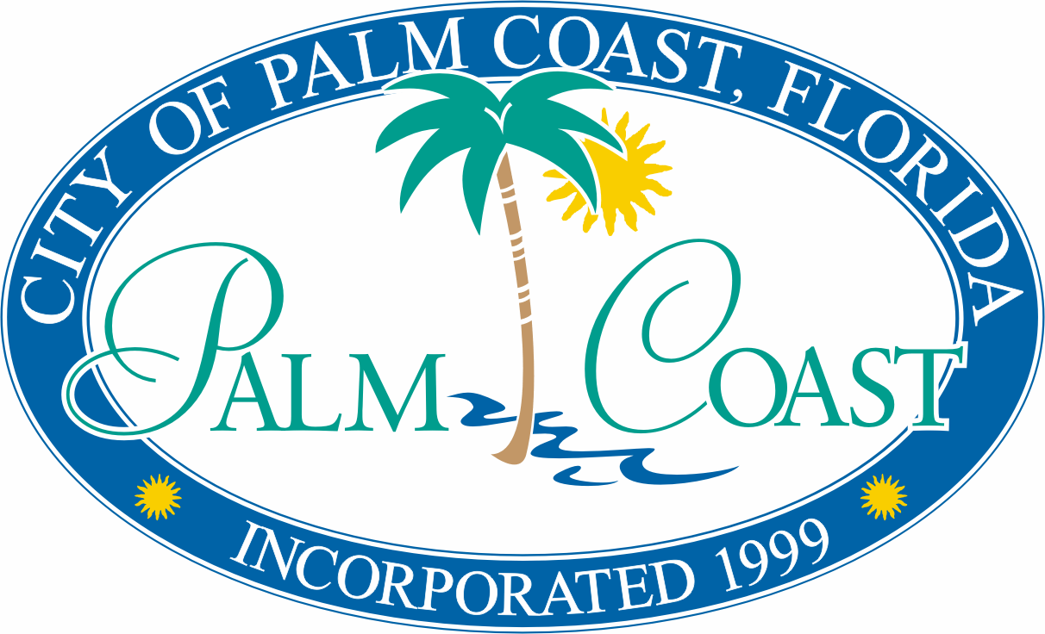

CITY OF PALM COAST
INVITATION TO BID
FOR
COMMUNITY DEVELOPMENT BLOCK GRANT

Bid #: ITB-CDBG-18-34

general description: The City of Palm Coast invites interested parties to submit a bid to furnish all labor and materials to rehabilitate five (5) single family homes for its Community Development Block Grant Housing Rehabilitation Program.

BID/PROPOSAL SOLICITATION DOCUMENTS: Solicitation documents are available at no-cost through the City’s Procurement Portal at (https://palmcoastgov.bonfirehub.com/portal).

SUBMITTALS: Responses must be submitted electronically through the portal by the specified time and date. No other method of submission will be allowed or considered (i.e. mailed, emailed, or hand delivered).

CONTACT/QUESTIONS: The City’s Central Services Division is the main point of contact for this solicitation. Specific contact information can be found in the Project Manual. Bidders/Proposers – DO NOT contact any other Palm Coast staff, nor any member of the City of Palm Coast City Council, or City Manager, regarding this solicitation at any time prior to the bid/request having been formally presented to, and voted on by, the City Council. Any such contact shall be cause for rejection of your bid/request submittal. Any questions concerning the intent, meaning and interpretations of the solicitation documents including the draft agreement, must be requested in writing through the portal at least seven (7) calendar days prior to the due date.

ADDENDA: Should revisions to the solicitation documents become necessary; the City will post addenda on the portal. Bidders/Proposers must sign, date, and return all addenda with the bid/proposal submittals. Therefore, it is recommended that Bidders/Proposers check the portal at least three (3) calendar days before both Deadline dates below to verify information regarding addenda. Failure to do so could result in rejection of the bid/proposal submittal as unresponsive.

AWARD: All submittals will be evaluated by City staff in accordance with the criteria set forth in the solicitation documents. The City reserves the right to reject all submittals, to waive any formalities, and to solicit and re-advertise for new bids/proposals, or to abandon the project in its entirety.

QUESTION DEADLINE: February 22, 2018 at 2:00 PM

MANDATORY PRE-BID/PROPOSAL MEETING: February 15, 2018 AT 10:30AM

BID/PROPOSAL DEADLINE: March 1, 2018 at 2:00 PM

PUBLIC OPENING: March 1, 2018 at 2:00 PM, or shortly thereafter, at City of Palm Coast City Hall, 160 Lake Avenue, Palm Coast, Florida 32164. Attendance not required.

ADA INFORMATION: Persons with disabilities needing assistance to participate in any of the proceedings should contact the City Human Resource Office ADA Coordinator at 386-986-3718 at least forty-eight (48) hours in advance of the public opening, pre-bid meeting, or any other proceeding related to this bid/proposal.

FOR PUBLICATION ON WEDNESDAY, February 7, 2018

CITY OF PALM COAST
CENTRAL SERVICES DIVISION – PURCHASING
160 LAKE AVENUE, PALM COAST, FL 32164
www.palmcoastgov.com
(386) 986-3730

